The Potter’s Hands

Scripture Reading: Jeremiah 18:1-11

Surrender to what is. Let go of what was. Have faith in what will be. —Sonia Ricotti

I
n 1902, Adelaide A. Pollard, a hymn writer, was hoping to go to Africa as a missionary but found herself unable to raise the needed funds to make the journey.

Greatly discouraged, she attended a prayer service one evening, and, as she sat there, she overheard an elderly woman say, “It really doesn’t matter what you do with us, Lord, just have your own way with our lives.”

The elderly woman inspired Pollard, and she thought about the story of the potter from Jeremiah 18:1-11 (today’s Old Testament reading). When she returned home that evening, she wrote all four stanzas of the well-known hymn, “Have Thine Own Way” before retiring for the night.

Have Thine own way, Lord! Have Thine own way!
Thou art the Potter, I am the clay.
Mold me and make me after Thy will;
While I am waiting, yielded and still.
Have Thine own way, Lord! Have Thine own way!
Hold o’er my being absolute sway!
Fill with Thy Spirit ’till all shall see
Christ only, always, living in me.

A potter needs a lot of strength to work with clay and get it centered properly. Clay often has a mind of its own, it seems. A potter must have strong fingers and arm strength.

God has these qualities. The arms of God are strong. They push and shape us. This is what God was showing to the prophet Jeremiah in our reading for today. The fingers of God apply the delicate touch needed to transform us into a work of art — at the hands of the Artist!

These are trying times. But if we yield to the creative hand of the Potter, something amazing and beautiful is going to happen! —Timothy Merrill

Prayer: O God, the Potter, today I surrender my life to you to mold and make according to your will. In Jesus’ name. Amen.

ACTIVITY PAGE for “The Potter’s Hands”

Verse to Remember

“Choose this day whom you will serve … but as for me and my household, we will serve the Lord.” ⎯Joshua 24:15

NAME THE STATE
In the space provided, write the names of the states in which the following
three-letter words are found:

EXAMPLE: OUT/ SOUTH DAKOTA

ASK:

SIP:

ORE:

EGO:

WAS:

ASH:

TON:

GIN:

CUT:

SEE:

INN:

USE:

SET:
ARITHMOGRAM
Place a number in each of the circles on either side of the squares so that the sum of the numbers in the adjoining circles equals the number in the square.

9
5

6

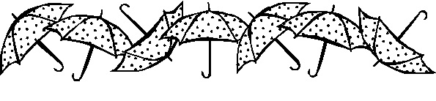

ANSWERS to NAME THE STATE:
ASK=Nebraska, or Alaska
SIP=Mississippi
ORE=Oregon
EGO=Oregon
WAS=Washington ASH=Washington TON=Washington GIN=Virginia CUT=Connecticut SEE=Tennessee INN=Minnesota USE=Massachusetts SET=Massachusetts

ANSWER:
Clockwise from the top circle —
4, 5, 1

Black Thunder

Scripture Reading: 1 Corinthians 10:1-13

In the depth of winter, I finally realized that there lay within me an invincible summer.
—Albert Camus.

O
ne fine day, on a ranch in southeastern Wyoming, not far from Cheyenne, a couple of boys about 10 years old were cutting across a small acreage bounded with barbed-wire fence. The terrain was uneven. As they walked through a small wadi, they suddenly came upon a fearsome bull they called “Black Thunder.” He couldn’t have been more than 30 yards away.

Something the boys did — or perhaps it was something they were wearing — agitated Black Thunder. It appeared he was going to charge.

The boys froze in their tracks, waiting to see what was going to happen.

Then Black Thunder started to move! The earth seemed to quake beneath his monstrous hooves! The barbed-wire fence seemed miles away!

One of the boys, being of good Baptist background, said, “Let’s stop and pray.”

The other boy said, “No, let’s run and pray!”

He knew that they didn’t need to battle the bull on its own turf; they needed to get to safe ground where they were not vulnerable, where the horns of the bull could not reach them and cause them injury or even death.

Often, that’s what we need to do when facing temptation or testing. No point in trying to be a hero.

But during this pandemic, we can’t run. There’s very little we can do. We’d love to “run and pray” like the boys in the pasture. Instead, we must “stay and pray” like the disciples when they were with Jesus before his betrayal.

The apostle Paul writes, “No testing has overtaken you that is not common to everyone. God is faithful, and he will not let you be tested beyond your strength, but with the testing he will also provide the way out so that you may be able to endure it” (1 Corinthians 10:13).

With God’s help, we will prevail against “Black Thunder.” We will endure. We can do this!
—Timothy Merrill

Prayer: Lord Jesus, I ask not to be free from testing, but to be made stronger because of it. Amen.

ACTIVITY PAGE for “Black Thunder”

Verse to Remember

“Why are you cast down, O my soul, and why are you disquieted within me? Hope in God; for I shall again praise him, my help and my God.” ⎯Psalm 43:5

BIRTH DATES … OR NOT?

DIRECTIONS: Is the year following each person’s name the year he or she was born, or the year he or she died? Write a B for “born” or a D for “died.”

Answers below.
PERSON | YEAR | B or D? |  | PERSON | YEAR | B or D?
William Shakespeare | 1616 |  |  | Mahatma Gandhi | 1869
Martin Luther | 1483 |  |  | Beethoven | 1827
Napoleon | 1769 |  |  | Joan of Arc | 1431
Henry Ford | 1863 |  |  | Aristotle | 322 BC
Julius Caesar | 44 BC |  |  | Elizabeth I | 1533
Cleopatra | 30 BC |  |  | Charles Darwin | 1882
Christopher Columbus | 1451 |  |  | Saint Francis | 1181
Marco Polo | 1324 |  |  | Constantine the Great | 337
Saint Augustine | 354 |  |  | Johann S. Bach | 1685
Michelangelo | 1564 |  |  | Rembrandt | 1606
Galileo | 1564 |  |  | John Milton | 1674
Charlemagne | 814 |  |  | Harriet Tubman | 1913
Abraham Lincoln | 1809 |  |  | Babe Ruth | 1895
Daniel Webster | 1852 |  |  | Jane Austen | 1775
Thomas Edison | 1931 |  |  | Edgar Allan Poe | 1849
Cicero | 43 BC |  |  | King Henry VIII | 1491
Calamity Jane | 1903 |  |  | Indira Gandhi | 1917
Florence Nightingale | 1820 |  |  | Leonardo da Vinci | 1452

Answers (in alphabetical
order by first or only word [name]):
Abraham Lincoln-B
Aristotle-D
Babe Ruth-B
Beethoven-D
Calamity Jane-D
Charlemagne-D
Charles Darwin-D
Christopher Columbus-B
Cicero-D
Cleopatra-D
Constantine the Great-D
Daniel Webster-D
Edgar Allan Poe-D
Elizabeth I-B
Florence Nightingale-B
Galileo-B
Harriet Tubman-D
Henry Ford-B
Indira Gandhi-B
Jane Austen-B
Joan of Arc-D
Johann S. Bach-B
John Milton-D
Julius Caesar-D
King Henry VIII-B
Leonardo da Vinci-B
Mahatma Gandhi-B
Marco Polo-D
Martin Luther-B
Michelangelo-D
Napoleon-B
Rembrandt-B
Saint Augustine-B
Saint Francis-B
Thomas Edison-D
William Shakespeare-D

My Boat Is So Small

Scripture Reading: Psalm 1

Dear Lord, be good to me, the sea is so wide, and my boat is so small. —Irish Fisherman’s Prayer

The poem below is an old Breton prayer that was given to new submarine captains by Adm. Hyman Rickover (1900-1986) who gave a plaque to President John F. Kennedy on which the first two lines were inscribed. Kennedy loved the prayer and, according to the John F. Kennedy Presidential Library and Museum website, he used it in his remarks at the dedication of the East Coast Memorial to the Missing at Sea, May 23, 1963. He kept the plaque on his desk in the Oval Office.

Thy sea, O God, so great,
My boat so small.
It cannot be that any happy fate
Will me befall
Save as Thy goodness opens paths for me
Through the consuming vastness of the sea.

Thy winds, O God, so strong,
So slight my sail.
How could I curb and bit them on the long
And salty trail,
Unless Thy love were mightier than the wrath
Of all the tempests that beset my path?

Thy world, O God, so fierce,
And I so frail.
Yet, though its arrows threaten oft to pierce
My fragile mail,
Cities of refuge rise where dangers cease,
Sweet silences abound, and all is peace.
—Attributed by some sources to Winfred Ernest Garrison (1874-1969)
—Timothy Merrill

Prayer: O God, thank you for peace in the midst of the storm. Amen.

ACTIVITY PAGE for “My Boat Is So Small”

Verse to Remember
“Jesus said to her, ‘I am the resurrection and the life. Those who believe in me, even though they die, will live, and everyone who lives and believes in me will never die. Do you believe this?’” ⎯John 11:25-26

Y IN THE WORLD!

Directions: The following words have no vowels except for a “Y,” which provides the sound of a short “i.” Use the clues to help you figure out the words.

1. ___ ___ Y ___ ___ : a vault, often beneath medieval churches, where the dead are entombed.
2. ___ ___ Y ___ ___ ___ : the beat and cadence of a song.
3. ___ Y ___ ___ ___ : a gift of the magi.
4. ___ Y ___ ___ ___ : a mythical maiden living in the forest or near the water.

Piece of the Pie
Arrange the numbers 1-8 so that, when a number is added to its opposite, it totals nine (9).

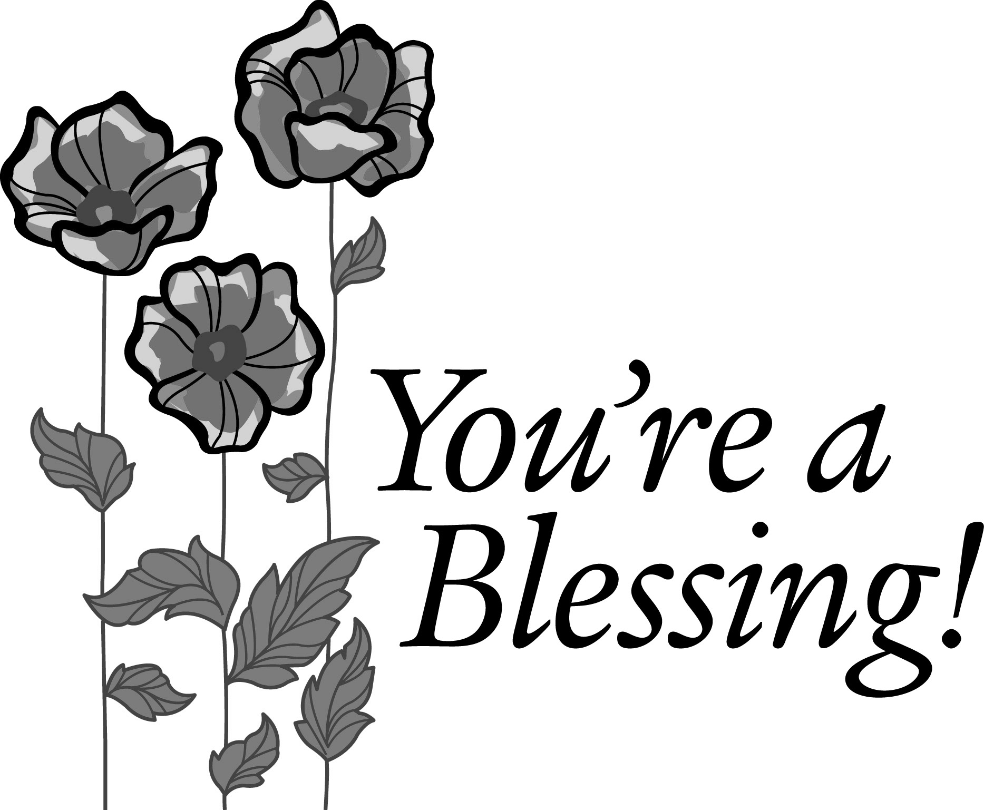

ANSWERS: Y IN THE WORLD!—1. crypt, 2. rhythm,
3. myrrh, 4. nymph. PIECE OF THE PIE — Start anywhere in this order, clockwise: 8,7,6,5,1,2,3,4. There is more than one arrangement.

The Candy Jar

Scripture Reading: John 3:1-17

God loves us the way we are, but too much to leave us that way. —Leighton Ford

In the reading above, we have what Martin Luther called “the gospel in a nutshell.” He was referring to John 3:16.

Love is a word that is used frequently and in many different ways in our culture. Here is a note written to Ann Landers some time ago: “Dear Ann: I’ve got to decide between the new car and getting engaged. I love the girl. But every night when I go to sleep I dream about the car. What should I do?”

The love mentioned in John 3:16 is not anything like the so-called love this young man was talking about. It is more like the love expressed in this story:

A little girl accompanied her mother to the country general store. After the mother had made a large purchase, the proprietor invited the girl to help herself to a handful of candy. The child held back.

“What’s wrong. Don’t you like the candy?” the proprietor asked.

“Yes, I love candy,” the child replied. Whereupon the proprietor put his hand into the jar and dropped a generous portion into the girl’s cupped hands.

Later, the mother asked the girl why she had not taken the candy when it was first offered.

“Because his hand is bigger than mine,” she replied.

God has the biggest hands of all. “God so loved the world,” says the Bible. God’s hands gave the biggest and best gift of all, Jesus Christ, the Savior of the world.
—Timothy Merrill

Prayer: O God, thank you for your big hands! Thank you for pouring out into my little hands all of your blessings. Thank you for sending Jesus to live and die for us. In Jesus’ name. Amen.

Activity Page for “The Candy Jar”

HERD, HORDE AND HUDDLE
Collective nouns are words that are given to groups of animals. That’s why we refer to kittens as a “litter of kittens.” When speaking of fish, we might say a “school of fish.” The words in the title above are collective nouns: a herd of goats, a horde of gnats and a huddle of penguins. Match the GROUP NAMES in Chart B to the ANIMALS in Chart A. (We did “Flamingoes” for you as an example.) Answers below.

CHART A : The Animals
Clams |  | Flamingoes | A | Raccoons |  | Turkeys
Coyotes |  | Foxes |  | Prairie dogs |  | Vultures
Crows |  | Geese |  | Porcupines |  | Zebras
Dolphins |  | Grouse |  | Owls |  | Wolves
Eagles |  | Hawks (flight) |  | Hyenas |  | Whales

CHART B: The Collective Nouns
A. Stand | I. Bed | Q. Gaze
B. Pack | J. Prickle | R. Murder
C. Rafter | K. Pod | S. Covey
D. Convocation | L. Zeal | T. Gaggle
E. Coterie | M. Skulk
F. Venue | N. Parliament
G. Cackle | O. School
H. Kettle | P. Band

Chart B: The Collective Nouns
A. Stand | E. Coterie | I. Bed | M. Skulk | Q. Gaze
B. Pack | F. Venue | J. Prickle | N. Parliament | R. Murder
C. Rafter | G. Cackle | K. Pod | O. School | S. Covey
D. Convocation | H. Kettle | L. Zeal | P. Band | T. Gaggle

Chart B: The Collective Nouns
A. Stand | E. Coterie | I. Bed | M. Skulk | Q. Gaze
B. Pack | F. Venue | J. Prickle | N. Parliament | R. Murder
C. Rafter | G. Cackle | K. Pod | O. School | S. Covey
D. Convocation | H. Kettle | L. Zeal | P. Band | T. Gaggle

ANSWERS:
A=Flamingoes
B=Wolves
C=Turkeys
D=Eagles
E=Prairie dogs
F=Vultures
G=Hyenas
H=Hawks
I=Clams
J=Porcupines
K=Dolphins
L=Zebras
M=Foxes
N=Owls
O=Whales
P=Coyotes
Q=Raccoons
R=Crows
S=Grouse
T=Geese

ANSWERS:
A=Flamingoes
B=Wolves
C=Turkeys
D=Eagles
E=Prairie dogs
F=Vultures
G=Hyenas
H=Hawks
I=Clams
J=Porcupines
K=Dolphins
L=Zebras
M=Foxes
N=Owls
O=Whales
P=Coyotes
Q=Raccoons
R=Crows
S=Grouse
T=Geese

ANSWERS:
A=Flamingoes
B=Wolves
C=Turkeys
D=Eagles
E=Prairie dogs
F=Vultures
G=Hyenas
H=Hawks
I=Clams
J=Porcupines
K=Dolphins
L=Zebras
M=Foxes
N=Owls
O=Whales
P=Coyotes
Q=Raccoons
R=Crows
S=Grouse
T=Geese

What do you call a group of frogs?
(an army, colony or knot of frogs)

ANSWERS:
A=Flamingoes
B=Wolves
C=Turkeys
D=Eagles
E=Prairie dogs
F=Vultures
G=Hyenas
H=Hawks
I=Clams
J=Porcupines
K=Dolphins
L=Zebras
M=Foxes
N=Owls
O=Whales
P=Coyotes
Q=Raccoons
R=Crows
S=Grouse
T=Geese

