THE PATH OF LIFE
Scripture Reading: Mark 2:1-12
Failure is delay, not defeat. ―William A. Ward

T
he national parks and wilderness areas of our country offer many opportunities for the outdoor enthusiast. One popular recreational activity is hiking.
Most experienced hikers understand that exploring trails may be sometimes difficult, time-consuming, and exhausting. But the views along the way make the effort worthwhile.
Newcomers, however, often don’t get it. That’s why the forest rangers at the Bridger Wilderness Area in Wyoming find it amusing to read some suggestions left at the ranger station on comment cards and registration sheets. These remarks are typical:

Trails need to be reconstructed so they don’t go uphill.
Trails need to be wider so people can walk holding hands.
Too many bugs and leeches and spiders. Please spray to get rid of these pests.
Please pave the trails so they can be plowed clear of snow during the winter.
Chairlifts need to be in some places so we can get to wonderful views without having to hike to them.
Escalators would help on steep uphill sections.
A McDonald’s would be nice at the trailhead.

Perhaps that is the way some Christians want to live life. They expect God to function as a divine Ranger whose sole job is to make our little trail smooth, straight and free of annoying pests along the way.
Of course, God has not promised us the way will be smooth or the path will be without difficulties. But God has promised to be with us on the journey. If we are faithful, we will be able to enjoy views that are out of this world — peace and joy that the world doesn’t understand.

Faithful God, may I be conscious of Your presence with me as I walk on the path of life. May I be grateful for the good things I experience along the way. Amen.

ACTIVITY PAGE – THE PATH OF LIFE
Verse to Remember
Say What?
Below is a group of scrambled words that, when properly unscrambled and arranged in the blanks, reveal a verse from one of Paul’s letters.

OHYRWT SPIIPPNIHLA EILF ILVE MRANEN EGSOLP UJSSE HTCSIR

_______ your ______ in a

_______ ________ of the

_______ of ______ ______.

―__________ 2:27
The Lord is my shepherd; I shall not want. ⎯ Psalm 23:1

What Are the Signs?
A Plus, a Times, a Minus or a Division sign?

Directions: Replace the question marks with math symbols that will yield the correct answer. Solution below.
2 ? 1 ? 6 ? 6 = 48
+ x ― ÷

Do You Remember?
If you were born in the 1930s or 1940s, you might well remember some world events that took place in the ’50s, ’60, and ’70s. Here are some questions about this era. Answers below.

1. For what disease did Dr. Jonas Salk and his team successfully create a vaccine in 1952?
2. What famous explorer climbed Mount Everest in 1953?
3. Which Olympic athlete set a record in 1972 by winning seven gold medals?
4. What deadly disease struck in Philadelphia in 1976 and was named for the convention where it struck?
5. What war ended on April 30, 1975?
6. What rising young star from the movie, Rebel Without a Cause, died in an automobile accident in 1955?
7. Which president resigned in early August 1974?
8. What newspaper heiress took part in a San Francisco bank robbery on April 15, 1974?
9. Who played the role of Norman Bates in the 1960 horror movie, Psycho?
10. What was the name of the 1961 conflict in which CIA forces tried but failed to invade Cuba and overthrow Fidel Castro?
11. Where was the inaugural New York City Marathon held in 1970?
12. Who was the first athlete to earn a perfect score in the history of Olympic gymnastics?
13. Russia captured and imprisoned U.S. pilot Gary Powers in 1960 for spying. What type of plane did he fly?
14. Who refused to give up her seat on the bus in Montgomery, Alabama, in 1955?

Solution to “What Are the Signs?” 2x1+6x6= 48; Answer to “Say What?”: Live your life in a manner worthy of the gospel of Jesus Christ. ―Philippians 2:27

Answers: 1. Polio; 2. Sir Edmund Hillary; 3: Mark Spitz; 4. Legionnaires’ disease; 5. The Vietnam War; 6. James Dean; 7. President Richard M. Nixon; 8. Patty Hearst; 9. Anthony Perkins; 10. Bay of Pigs; 11. Central Park; 12. Nadia Comaneci; 13. U-2; 14. Rosa Parks
FORGIVENESS

Scripture Reading: Luke 4:1-13

Forgiveness does not change the past,
but it does enlarge the future. —Paul Boese

H
e was crazy. At least this is what most people thought. That’s because the man had the habit of talking to himself in public, and he claimed he was talking to Jesus and Jesus was talking to him.
A new preacher came to town and, hearing of the addled gentleman, thought that he might be able to make him face reality.
One day, as the preacher saw the man walking down the street, he spoke to him and eventually got around to saying, “I hear you talk to Jesus.”
“Thas right,” he said. “Jesus and I talks fer jist hours and hours.”
“Would you do me a favor?” the minister asked. “Could you ask him something for me?”
“Sure. Sure can. Sure will.”
“Would you ask Jesus what the last sin was that I confessed to him?”
“I’ll ask,” he said. “Certainly, I will ask.”
The next day, the preacher saw the Jesus-talking fellow and ran down the street. He caught up to him and asked, “Well, did you talk to Jesus last night?”
“Yessir, yessir, I surely did,” he said.
“What did he say was the last sin that I confessed to him?” the preacher asked, sort of smug-like.
“Well, here’s sumptin’ now.” The old guy raised a bony hand to his chin, puzzled. “He said he didn’t remember what was the last sin you confessed and he quoted Scripture, too.”
“And what was that?” the astonished clergyman asked.
“Not for certain, but I think it was Psalm 103.”
As far as the east is from the west, so far he removes our transgressions from us (Psalm 103:12. See also Jeremiah 31:34: “For I will forgive their iniquities and will remember their sin no more.”)

Thank You, Lord, for cleansing me of my sins, and for remembering them no more! Help me to live worthily of Your great love. Amen.
—Timothy Merrill

ACTIVITY PAGE – FORGIVENESS
Verse to Remember
Bear with one another and, if anyone has a complaint against another, forgive each other; just as the Lord has forgiven you, so you also must forgive. ―Colossians 3:13
Words that Begin with “O”
Directions: First, try to fill in the correct word based solely on the definition provided. If needed, consult the word list for help. Answers below.
optical oblivion olfactory optimize oxymoron ostracism opulence orthodox optional obsidian ominous obfuscate obstacle obituary ointment

1. Adhering to the accepted or traditional and established faith, especially in religion _____________________
2. Of, relating to, or contributing to the sense of smell _____________________
3. Something that stands in the way of or holds up progress ___________________
4. The condition or quality of being completely forgotten _____________________
5. A published notice of a death, sometimes with a brief biography of the deceased _____________________
6. A highly viscous substance used on the skin; a salve ___________________
7. A usually black or banded, hard volcanic glass that displays shiny, curved surfaces
when fractured and is formed by rapid cooling of lava ___________________
8. To make as perfect or effective as possible _____________________
9. A rhetorical figure in which incongruous or contradictory terms are combined _____________________
10. Great abundance or extravagance _____________________
11. Left to choice; not compulsory or automatic _____________________
12. Of or relating to sight; visual ___________________
13. Menacing; threatening ___________________
14. To make so confused or opaque as to be difficult to perceive or understand ___________________
15. The act of banishing or excluding ___________________
Answers to WORDS THAT BEGIN WITH O: 1. orthodox, 2. olfactory, 3. obstacle, 4. oblivion, 5. obituary, 6. ointment, 7. obsidian, 8. optimize,
9. oxymoron, 10. opulence, 11. optional, 12. optical, 13. ominous, 14. obfuscate, 15. ostracism

REJOICING IN LIFE
Scripture Reading: 1 Corinthians 15:35-38, 42-50

Those who have courage to love should have
courage to suffer. —Anthony Trollope

H
ave you noticed that our Christian faith doesn’t talk a lot about death? True, the Bible mentions death and dying, but not a whole lot. Jesus comforted his disciples in John 14 when he said, “Let not your hearts be troubled …” but that’s about it. Of course, Jesus spoke of his own death, but did not get too philosophical on the subject of death.
What Jesus, and certainly the Bible, does emphasize is life!
In today’s reading, the apostle Paul teaches us what will happen to our bodies at the last resurrection. A few other passages in Scripture speak of death, often in the context of the second coming of Christ.
But the focus of our Christian faith is on life. Jesus spoke frequently about life, having life, getting a life, giving away a life and eternal life. He said, “I came that they might have life and have it abundantly” (John 10:10b).
In other religions of the world, many rituals are associated with death, sometimes lasting for months. In our practice, some Christians may have a rosary, then a service, a few brief words at the graveside and that’s it. We do not see death as the end but as a beginning. Death is not the end of life but only the end of life as we know it. When someone dies, we gather to say goodbye as though the deceased has left on a journey on which we have not yet embarked.
So, we do not “grieve as others do who have no hope” (1 Thessalonians 4:13). Let’s rejoice in life. It is eternal life! Its form may someday change, but we shall live forever. “Those who believe in me,” Jesus said, “even though they die, will live” (John 11:25).

Giver of life, I am grateful for the gift of Your love and Your everlasting life. Grant me the grace to enjoy it here in this world while preparing to enjoy it in the next. Amen.

ACTIVITY PAGE – REJOICING IN LIFE
Verse to Remember
“I came that they may have life and have it abundantly.” ―John 10:10
The Story of David and Goliath, from 1 Samuel 17
Find the CAPITALIZED words in the Word Search below. The words may be vertical, horizontal or backward.

The CHAMPION, the Philistine of Gath, GOLIATH by name, came up out of the ranks of the Philistines, and spoke the same words as before. And David heard him. All the Israelites … fled from him and were very much afraid. … David said, “What shall be done for the man who kills this Philistine, and takes away the REPROACH from ISRAEL?” … David said, “The Lord, who saved me from the paw of the lion and from the paw of the bear, will save me from the hand of this PHILISTINE.” Then he took his staff in his hand, and chose five smooth stones from the wadi, and put them in his SHEPHERD’s bag, in the pouch; his sling was in his hand, and he drew near to the Philistine. When the Philistine looked and saw David, he disdained him, for he was only a youth, RUDDY and HANDSOME in appearance. The Philistine said to David, “Am I a dog, that you come to me with sticks?” And [Goliath] cursed David by his gods. [He] said to David, “Come to me.” … But David said … “You come to me with SWORD and SPEAR and JAVELIN; but I come to you in the name of the Lord of hosts.” … When [Goliath] drew nearer to meet David, David ran quickly … to meet the Philistine. DAVID put his hand in his bag, took out a stone, slung it, and struck the [Goliath] on his FOREHEAD; the stone sank into his forehead, and he fell face down on the ground. So David prevailed over the Philistine with a sling and a stone, striking down the Philistine and killing him; there was no sword in David’s hand. Then David ran and stood over the Philistine; he grasped his sword, drew it out of its SHEATH, and KILLED him; then he cut off his head.



DRILL DOWN
Directions: Place the letters of the two 9-letter words below on the empty lines, one letter per space, to spell a 7-letter, 5-letter and 3-letter word. Each letter is used only once.
1. SOMEPLACE
__ R __ B __ E __
__ C __ R __
__ U __
2. SALVATION
__ N __ T __ L __
__ D __ P __
__ A __

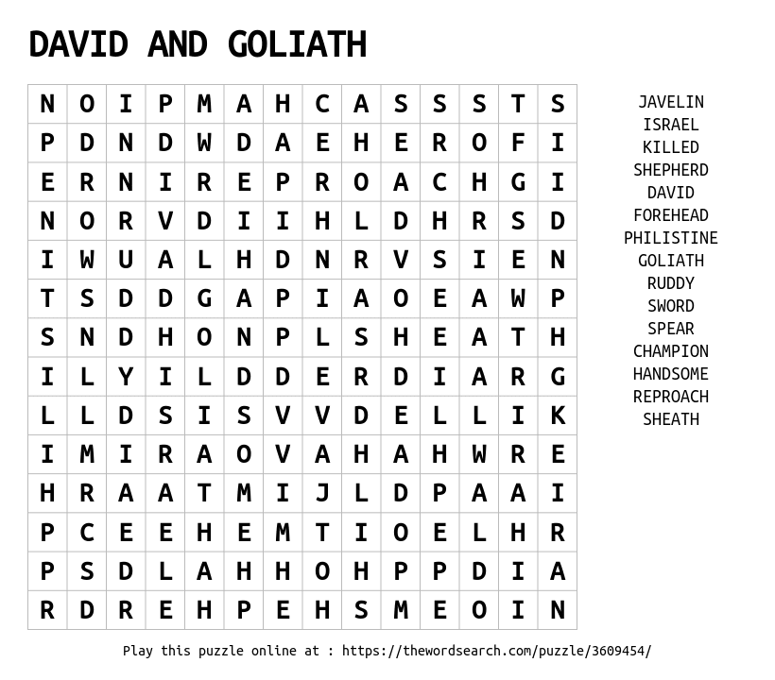

Answers to DRILL DOWN: 1. problem, scare, cue
2. install, adopt, van

HONESTY
Scripture Readings: Matthew 25:31-46
Honesty is more than not lying. It is truth telling,
truth speaking, truth living and truth loving! —James E. Faust

O
ur subject for today is honesty.
Most of us would agree that “honesty is the best policy.” Sometimes, it is hard to be honest — to be a person of integrity. When we look at others, we might notice that the people who often get ahead are not so noble in their character. Let me assure you: Your reputation as an honest person is worth more than gold. Resist the temptation to be anything less than trustworthy and honest. The following story emphasizes this truth in a humorous way.
During the Great Depression a farmer in Iowa sold a pound of butter to the local baker.
One day, the baker decided to weigh the butter. He was suspicious. He didn’t believe he was getting the right amount of butter for what he was paying. So he weighed it. And his suspicions were confirmed! The farmer was cheating him!
The baker was very angry and took the farmer to small claims court in Osage. The judge asked the farmer if he was using any measure to weigh the butter. The farmer replied, “Your honor, I don’t have a big farm, and it’s a pretty basic operation. So I don’t have a proper measure, but I do use a scale.”
“So how, then, do you weigh the butter which you sell to the baker?” the judge asked.
“Well, that’s the thing, your honor. Curious, you know? Years ago, I began buying a pound loaf of bread from the baker. Then he mentioned he wanted a pound of butter. I didn’t have a measure, but this was easy. I just used his pound loaf on the scale to measure the pound of butter I give him. So if there’s a problem, it’s because his pound loaf is not a pound loaf!”
Václav Havel (1936-2011), Czech statesman, playwright and erstwhile dissident, said that “Lying can never save us from another lie.” So rather than weaving a web of lies in which we ourselves are likely to be snared, it is much better to practice honesty. Author Adrienne Posey observed that it is better to be honest; it leaves little room for error.

O God, to be dishonest is to reveal a lack of faith in You. And You have given me no reason not to trust You. Thank You for Your help, strength and grace each day. In Jesus’ name. Amen.

ACTIVITY PAGE – HONESTY

Verse to Remember
So then, putting away falsehood, let all of us speak the truth to our neighbors, for we are members of one another. ― Ephesians 4:25
Top 10 Males in the Bible: 1. Jesus, 953 or more mentions; 2. David, 881; 3, Moses, 804; 4. Judah, 756; 5. Jacob, 366; 6. Saul, 328; 7. Aaron, 318; 8. Solomon, 262; 9. Abraham, 231; 10. Joseph, 222. (Numbers may vary slightly based on Bible version and/or website.) Top 10 Females in the Bible: 1. Sarah/Sarai, 59 mentions; 2. Esther, 57; 3. Rachel, 48; 4. Leah, 34; 5. Rebekah, 31; 6. Jezebel, 23; 7. Mary, the mother of Jesus, 19 mentions by name (and a few more in John as the mother of Jesus); 8. Miriam, 14; 9. and 10. (tie) Mary Magdalene and Ruth, 13

Who’s Who?
Top 10 Males in the Bible: Can you identify the top 10 most common male characters in the Bible? Jesus comes in first, with about a thousand mentions. Choose your picks for the other nine, from the least to most mentions. Answers below.
Aaron, Abraham, Absalom, Amos, Andrew, Barnabus, Bartholomew, Cephas, David, Eli, Elijah, Elisha, Enoch, Esau, Ezra, Gideon, Hezekiah, Herod, Isaiah, Ishmael, Jacob, John, Joseph, James, Jonathan, Jeremiah, Jesse, Jonah, Job, Joel, Judah, Lazarus, Levi, Lot, Luke, Mark, Matthew, Moses, Nathanael, Nehemiah, Nicodemus, Noah, Paul, Peter, Pharaoh, Pilate, Samuel, Saul, Simon, Solomon, Stephen, Timothy
10. _____________ 9. ______________ 8. _______________
7. _______________ 6. _______________ 5. _______________
4. _______________ 3. _______________ 2. _______________
1. JESUS
Top 10 Females in the Bible: Now try to identify the top 10 most common female names in the Bible. Write your answers here, from least to most mentions.
10. _____________ 9. ______________ 8. _______________
7. _______________ 6. _______________ 5. _______________
4. _______________ 3. _______________ 2. _______________
1. _______________
Abigail, Anna, Bathsheba, Deborah, Delilah, Dinah, Dorcas, Elizabeth, Esther, Eve, Hagar, Hannah, Jezebel, Leah, Lydia, Martha, Mary Magdalene, Mary (mother of Jesus), Miriam, Naomi, Rachel, Rahab, Rebekah, Ruth, Sarah
Can you do this in two minutes?
Here are 10 short words, all with the letter F in them. Can you unscramble them in two minutes? That’s about 12 seconds per word. Try it!
yfl _____________________

tefe _____________________

hsfi _____________________

gofr _____________________

ofx _____________________

nfa _____________________

rouf _____________________

rokf _____________________

evfi _____________________

fcea _____________________

